KICKSTART Server Installation In Linux (REdhat or CentOS 6)

KICKSTART SERVER
this server is used for remote installation & Automatic installation of o/s
steps :
keep rhel or centOS 5 or 6 dvd in cdrom
#mount /dev/cdrom /mnt
#cd /mnt
#cd Server
#rpm -ivh pykickstart-0.43-1.el5.noarch.rpm --force --aid
#system-config-kickstart-2.6.19.1-1.el5.noarch.rpm --force --aid
enter below command
#system-config-kickstart
open screen like below screen shots..
we have provided screen shots for this
save this file under /var/ftp/pub(with a name with .ks extension)
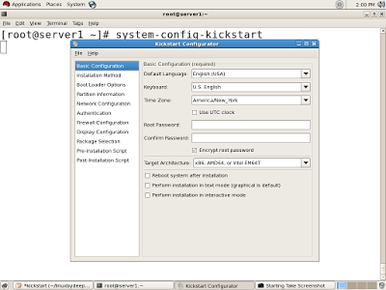

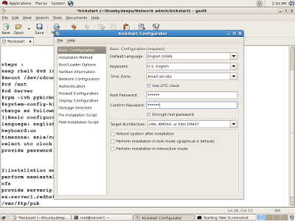

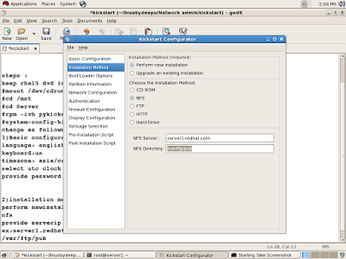
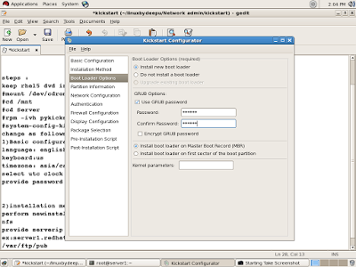
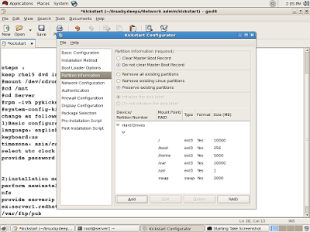
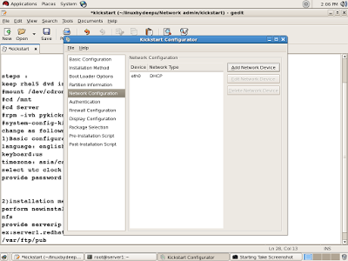
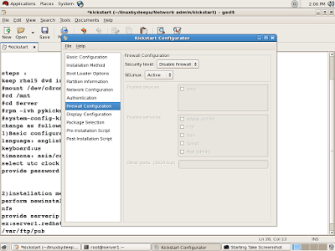
client side:
place linux bootable cd
type
linux ks:nfs://<server ip>/var/ftp/pub/<ks filename>
installation is starttttttt..........................

